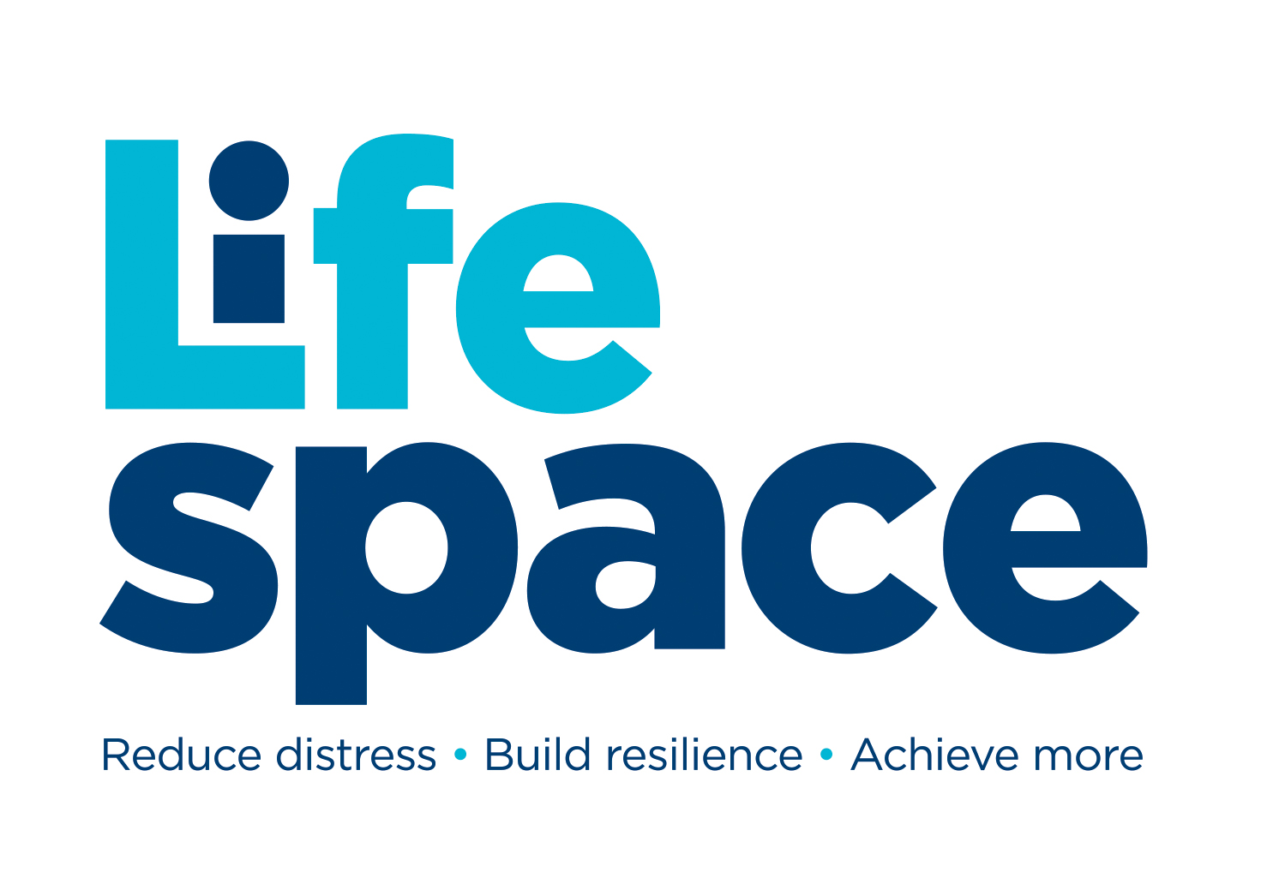
SCHOOL/COLLEGE (CONTRACT/PAYG)
ONE TO ONE MENTORING REQUEST FORM
“We mentor young people to reduce distress, build resilience & achieve more”

TELL US ABOUT THE YOUNG PERSON

Full Name
Preferred Name
Pronouns
Gender
Date of Birth
School/College Name
Year Group
Current Attendance %

REASON FOR REQUESTING ONE-TO-ONE MENTORING

Reasons for mentoring? Please include as much relevant information about the young person:

In what ways will mentoring address the issues? Please mention specific intended outcomes:

Checklist
PREFFERRED SESSIONS: | Face to Face / Phone / MS Teams / Any of these
PERMISSION: | Has mentoring by face to face / telephone / MS Teams been explained to the young person? | Yes / No
 | Has consent been gained from a parent/carer for the above? | Yes / No
 | Has the young person agreed to mentoring? | Yes / No
STRATFORD RESIDENT: | Does the young person have a Stratford home postcode? | Yes / No /Unsure
SEN: | Does this young person have Special Educational Needs? | Yes / No / Unsure
RISE: | Have they been referred to RISE? | Yes / No / Unsure
PP: | Are they accessing Pupil Premium? | Yes / No / Unsure
CLA: | Are they Care Experienced? | Yes / No / Unsure
Child Protection: | Is there a child protection plan in place? | Yes / No / Unsure
Early Help | Has there been an Early Support/Family Help/Targeted support or Family Help assessment for the family | Yes / No / Unsure
NB. You MUST complete the Risk Assessment over the page

RISK ASSESSMENT
TELL US ABOUT CURRENT RISKS observed or known about:
Has the young person you are completing this on behalf of: | Never | Past 1-4 weeks | Past 1-6 months | Past 6-12 months | More than a year ago
Harmed themselves
(include use of alcohol/drugs):
Been harmed by others:
Inflicted harm on others:
Experienced loss:
Had thoughts of suicide:
Witnessed Domestic Abuse:

*Please note - we are willing to work alongside other professionals where:
1. The young person has already attempted suicide - contact should also be made with RISE / GP / CAMHS
2. There is a recent or expected family bereavement – also contact a specialist service
3. The young person is witness to domestic abuse / experienced physical abuse – also contact a specialist service

Does anything specific need to be considered to manage the risks with this request? Yes / No

Who to keep informed / other comments:

Signed by person authorising request: Date:

Your relation to young person (circle): Teacher / Pastoral staff / Other (specify):

Your email: Phone no.

---------------------------------------------------------------------------------------------------------------------------------

WHO TO INVOICE FOR THE MENTORING (Please delete as appropriate)

Who is paying for the mentoring? School (contract) / School (PAYG) / Other (specify):

Contact details for the invoice if not School:
(Please include postal address, email address and phone number)

---------------------------------------------------------------------------------------------------------------------------------
TERMS, CONDITIONS AND PRIVACY POLICY
- If we consider it necessary in order to safeguard and/or promote a young person's welfare, we will contact DSL at school and/ or other agencies
- Ordinarily we will seek the young person’s consent (or parent's/carer's consent as necessary) but there may be occasions we do not, if doing so places young person at risk or causes delay
- The information shared on this form is strictly confidential and is only for the attention of Lifespace Trust. Its is not to be shared & must be stored securely.


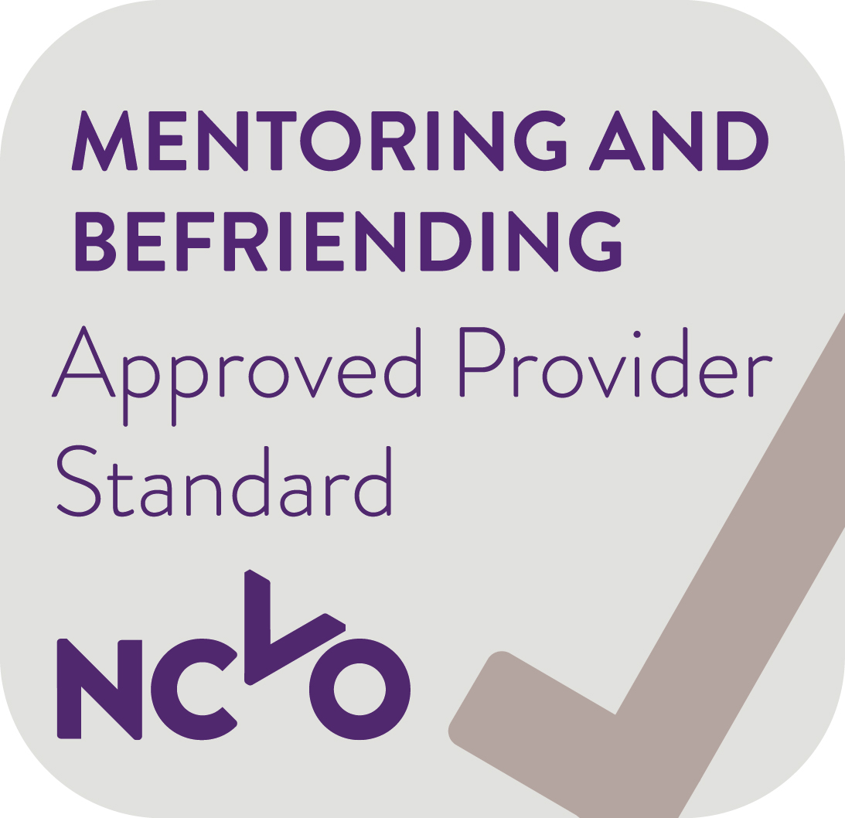
Lifespace Trust, Tyler House, Tyler St, Stratford-Upon-Avon, Warks. CV37 6TY
Tel: 01789 297400 Email: admin@lifespace.org.uk Web: www.lifespace.org.uk

Lifespace Trust is an Approved Provider & has been awarded The Queen’s Award for Voluntary Service

